INTERIM PROJECT REPORT
Ilaha Behbudova
Project Title: Measuring Gender, Age, and Nationality Bias in Transformer-Based Language Models: A Comparative Study of BERT and RoBERTa
George Washington University & ADA University
CSCI 6917/6918 – Guided Research Methods
Date: 13 July 2026

Table of Contents
1. Introduction 3
2. Related Work 3
3. Technical Approach 3
4. Software Architecture 4
5. Dataset 4
6. Implementation Progress 5
7. Preliminary Results 5
8. Discussion 7
9. Risks 7
10. Current Status and Future Work 8
11. References 8

1. Introduction
Large language models and transformer-based masked language models are increasingly integrated into applications that influence information access and decision-making. Since these models learn from large collections of human-written text, they may inherit demographic stereotypes present in their training data. This project investigates demographic bias in BERT and RoBERTa using the CrowS-Pairs benchmark. Rather than demonstrating that bias exists, the objective is to compare two transformer architectures under identical experimental conditions.

2. Related Work
Previous studies have shown measurable social bias in masked language models. Devlin et al. introduced BERT, while Liu et al. later proposed RoBERTa using improved pretraining strategies. Nangia et al. introduced CrowS-Pairs as a benchmark for evaluating social bias. These works motivate the current study, which focuses specifically on gender, age and nationality using a consistent evaluation pipeline. You can find all the work until this time from my github repository, https://github.com/ibehbudova7711/Guided_Research_Methods.git .

3. Technical Approach
The experimental pipeline was implemented in Python using PyTorch, Hugging Face Transformers, Pandas and Matplotlib. The evaluation follows the pseudo-log-likelihood (PLL) approach commonly adopted for masked language models. For every CrowS-Pairs sentence pair, PLL scores are calculated for both the stereotypical and less stereotypical sentence. The sentence receiving the higher PLL score is considered the model's preferred sentence.

4. Software Architecture
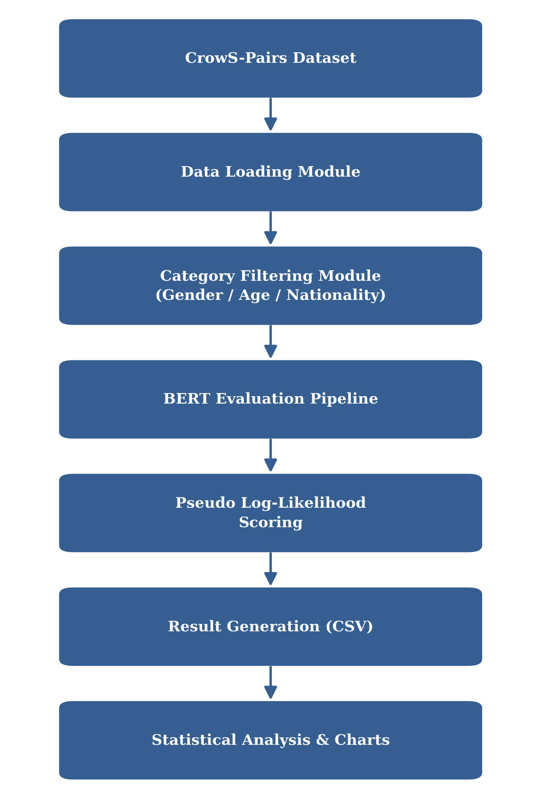
Figure 1. Software architecture of the BERT evaluation pipeline, from raw CrowS-Pairs data to statistical analysis and visualization.
The current implementation completes the BERT pipeline. The same architecture will be reused for RoBERTa during the final stage, ensuring a controlled comparison.

5. Dataset
The original CrowS-Pairs dataset contains 1,508 sentence pairs across multiple demographic categories. The dataset was filtered to include only gender (262), nationality (159) and age (87), producing a final evaluation set of 508 examples.

6. Implementation Progress
Completed tasks include dataset exploration, preprocessing, filtering, integration of bert-base-uncased, implementation of PLL scoring, validation using sample sentence pairs, evaluation of all 508 filtered examples, CSV export, summary statistics and visualization generation. The evaluation pipeline has been tested successfully on the complete filtered dataset.

7. Preliminary Results
The current BERT evaluation produced the following results: stereotypical preference in 277 of 508 examples (54.53%) and less stereotypical preference in 231 examples (45.47%). Category-level analysis showed stereotypical preference rates of 60.92% for age, 57.25% for gender and 46.54% for nationality. These results indicate measurable variation across demographic categories rather than a uniform level of bias.
Preliminary Findings
At the current stage of the project, BERT has been successfully evaluated on the filtered CrowS-Pairs dataset containing 508 sentence pairs across gender, age, and nationality categories. Preliminary results indicate that BERT preferred stereotypical statements in 54.53% of the evaluated examples. Among the three categories, age produced the highest stereotypical preference rate (60.92%), followed by gender (57.25%), while nationality showed a lower rate (46.54%). These findings are preliminary because the comparative evaluation with RoBERTa has not yet been completed. The final report will compare both models under identical experimental conditions and discuss whether differences between the models are statistically meaningful.
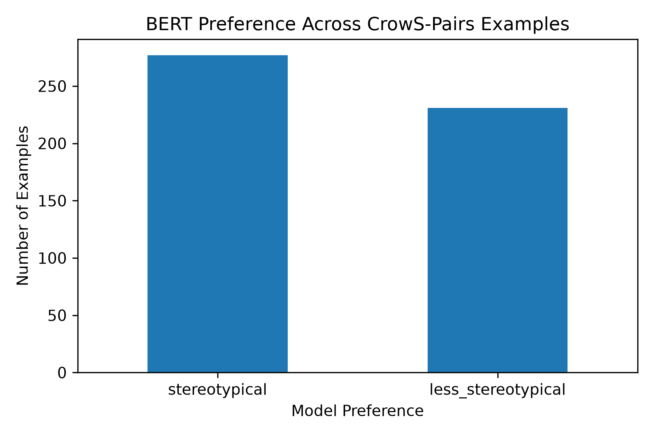
Figure 2. Overall BERT preference on the filtered CrowS-Pairs dataset (508 sentence pairs). BERT preferred the stereotypical sentence in 277 cases (54.53%) and the less stereotypical sentence in 231 cases (45.47%).
Figure 2 shows the overall evaluation results obtained from the CrowS-Pairs dataset. Across the 508 evaluated sentence pairs, BERT selected the stereotypical sentence slightly more often than the less stereotypical alternative. This indicates that the model exhibits a measurable tendency toward stereotypical associations under the experimental setup used in this project. While the difference is not large, the result suggests that demographic bias remains present in the pre-trained model.
Table 1. Overall BERT Evaluation Results
Preference | Number of Examples | Percentage
Stereotypical | 277 | 54.53%
Less Stereotypical | 231 | 45.47%

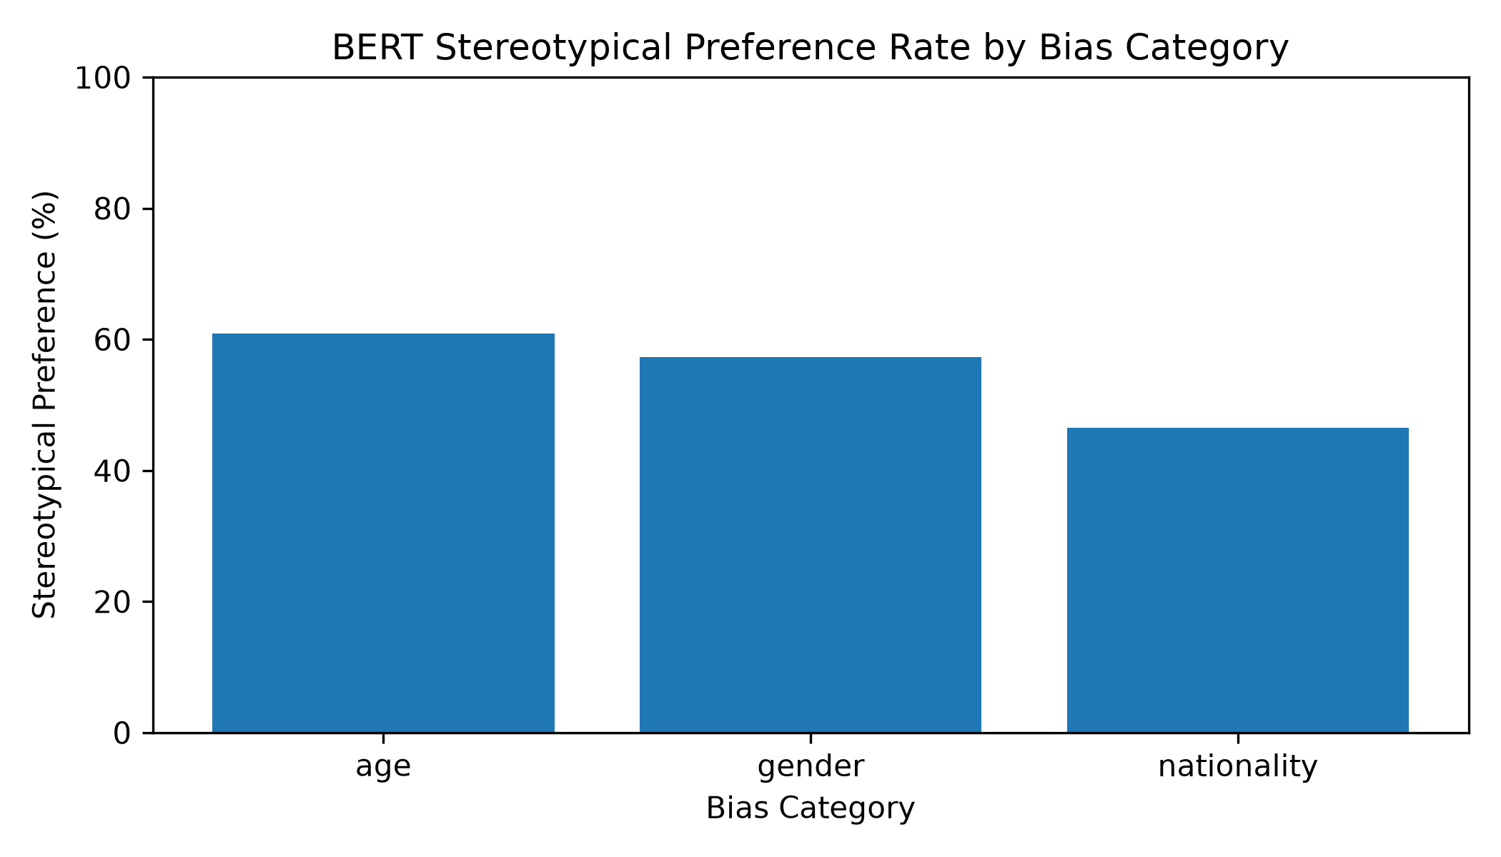
Figure 3. Percentage of stereotypical sentence preferences across the three demographic categories evaluated in BERT model.
Figure 3 presents the stereotypical preference rate for each demographic category. Age-related examples produced the highest stereotypical preference rate (60.92%), followed by gender (57.25%). Nationality produced the lowest rate (46.54%), indicating that BERT showed comparatively less stereotypical behavior for this category. These results are preliminary because RoBERTa has not yet been evaluated, but they provide an initial indication that bias may vary depending on the demographic dimension being examined.

8. Discussion
The observed preference rate is only moderately above 50%, indicating that BERT does not always prefer stereotypical statements. Nevertheless, the benchmark suggests a consistent tendency toward stereotypical associations for age and gender. These findings should be interpreted within the limitations of the CrowS-Pairs benchmark and should not be generalized to every real-world application.

9. Risks
CrowS-Pairs cannot capture every form of demographic bias. Some examples contain overlapping demographic attributes, making complete separation difficult. Furthermore, the age subset contains fewer examples than the other selected categories, which may affect statistical stability.

10. Current Status and Future Work
The project remains on schedule. The BERT evaluation pipeline has been completed and validated. The remaining work consists of implementing the identical pipeline for RoBERTa, performing a comparative analysis, discussing mitigation strategies reported in the literature, and preparing the final report and presentation.

11. References
1. Devlin, J., et al. (2019). BERT: Pre-training of Deep Bidirectional Transformers for Language Understanding.
2. Liu, Y., et al. (2019). RoBERTa: A Robustly Optimized BERT Pretraining Approach.
3. Nangia, N., et al. (2020). CrowS-Pairs: A Challenge Dataset for Measuring Social Biases in Masked Language Models.
4. Nadeem, M., et al. (2021). StereoSet: Measuring stereotypical bias in pretrained language models.

